**Largest number (q11)**

#include <iostream>

using namespace std;

int main()

{

int n1 = 5, n2 = 10, max;

max = (n1 > n2) ? n1 : n2;

cout << "Largest number between "

<< n1 << " and " << n2

<< " is " << max << ".";

return 0;

}

**OUTPUT:**

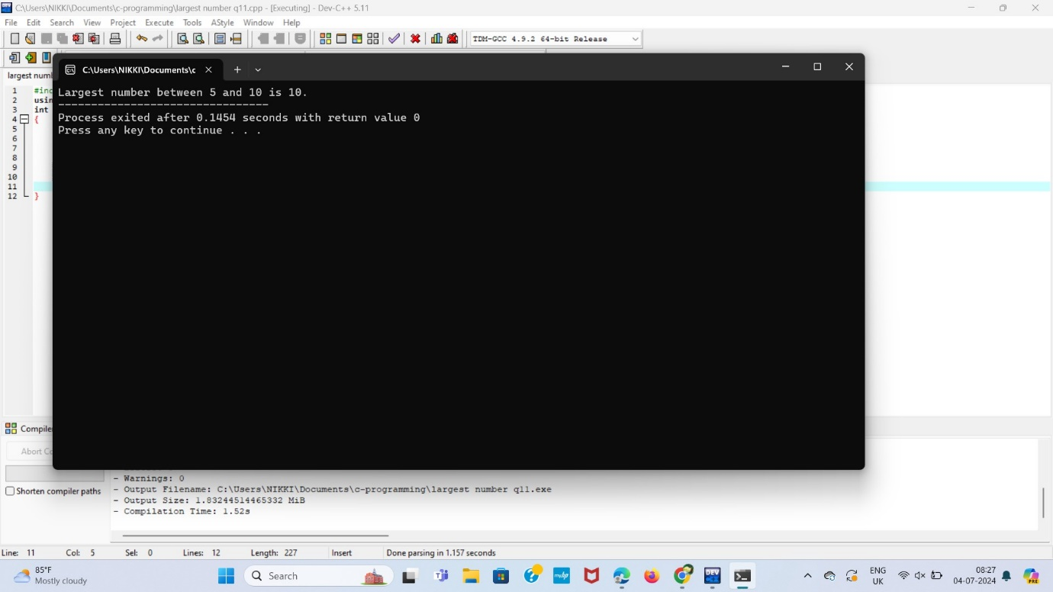

**LONG NUMBER(Q12)**

#include<iostream>

using namespace std;

int main()

{

long long int n = 657453;

if(n%3 == 0)

{

cout<< "yes";

}

else{

cout<< "no";

}

return 0;

}

**OUTPUT:**

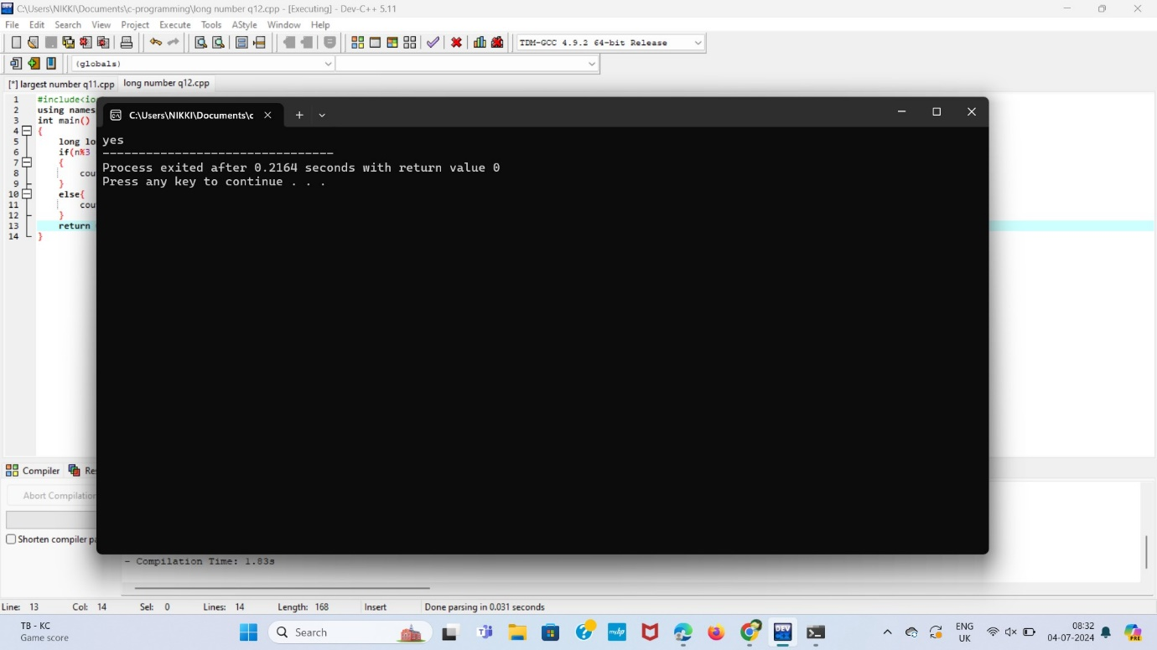

**COUNTING NUMBERS(Q13)**

#include<iostream>

using namespace std;

int main()

{

int n = 10;

int i;

for(i=1;i<=n;i++){

cout<<i<<" ";

}

return 0;

}

**OUTPUT:**

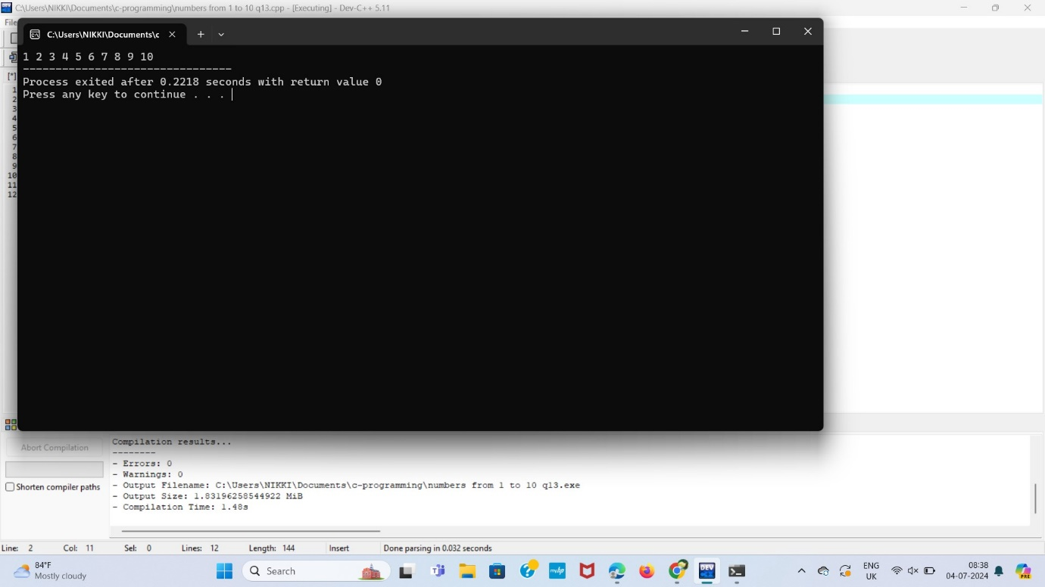

**FACTORIAL (Q14)**

#include<iostream>

using namespace std;

unsigned int factorial(unsigned int n)

{

int x = 1, i;

for (i = 2; i <= n;i++)

x *= i;

return x;

}

int main()

{

int num = 5;

cout<<"factorial of"<<num<<" is "

<< factorial(num) << endl;

return 0;

}

**OUTPUT:**

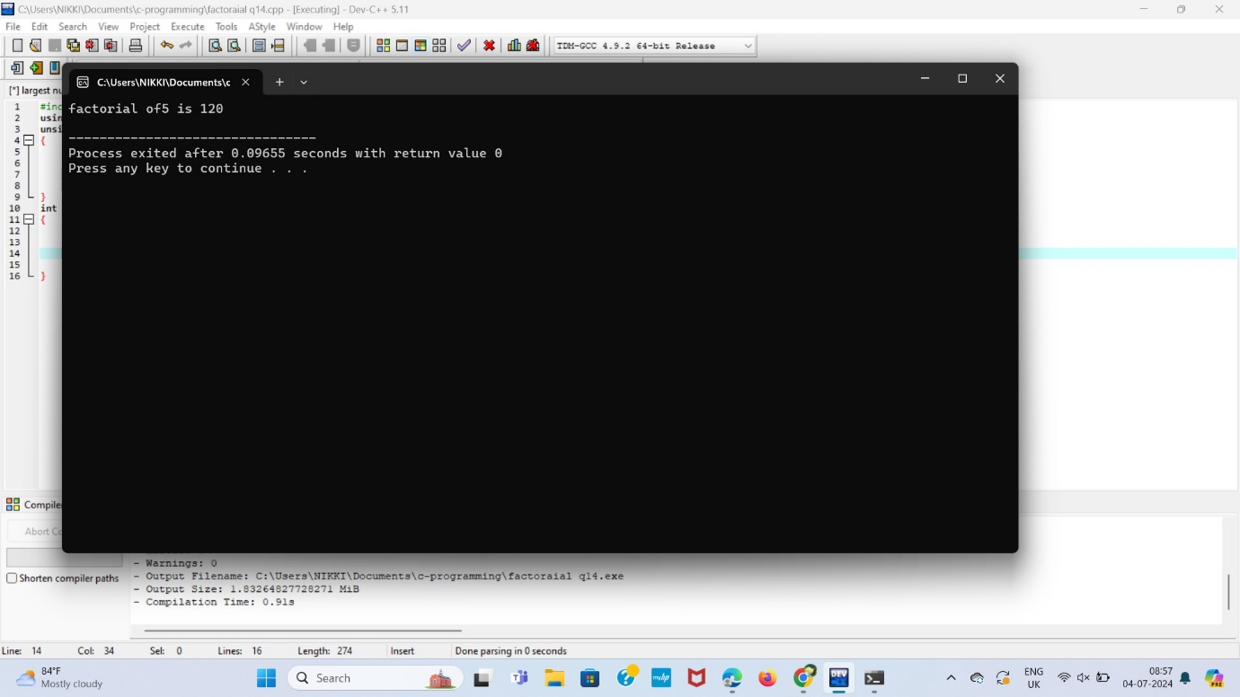

**DIVISIBLE BY 3 (Q15)**

#include <iostream>

using namespace std;

int main()

{

long long int n=769452;

if (n % 3 ==0)

{

cout << "Yes";

}

else

{

cout << "No";

}

return 0;

}

**OUTPUT:**

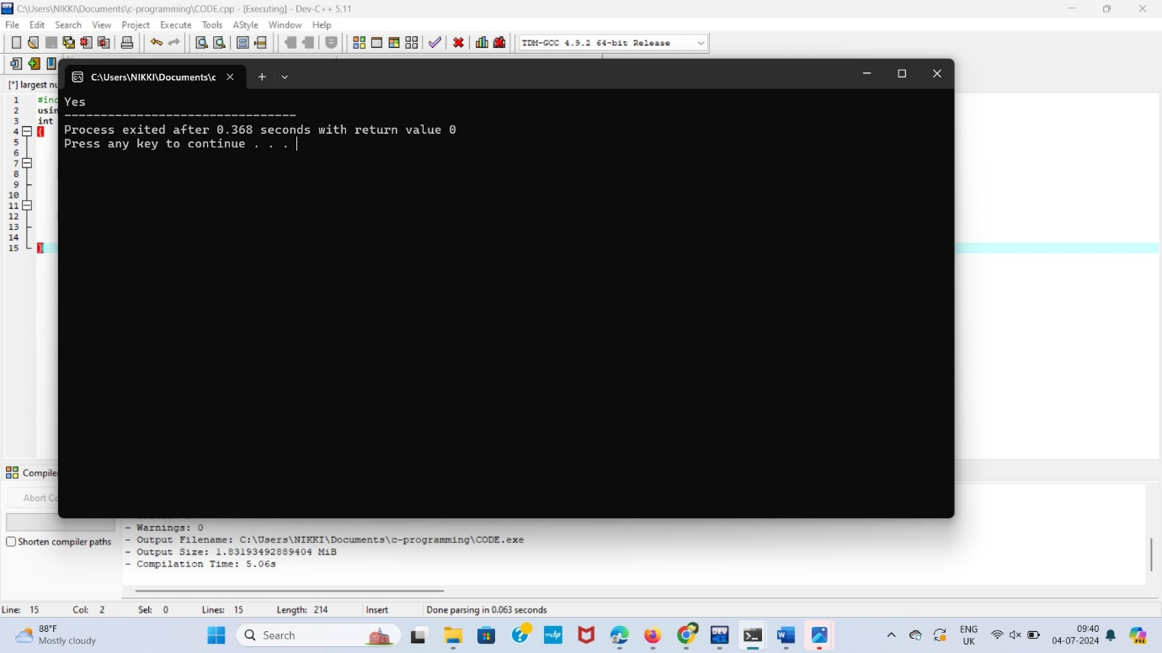

**MULTIPLICATION TABLE (Q16)**

#include <iostream>

using namespace std;

int main(){

int n = 5;

for (int i = 1; i <= 10; ++i)

cout << n << " * " << i << " = " << n * i << endl;

return 0;

}

**OUTPUT:**

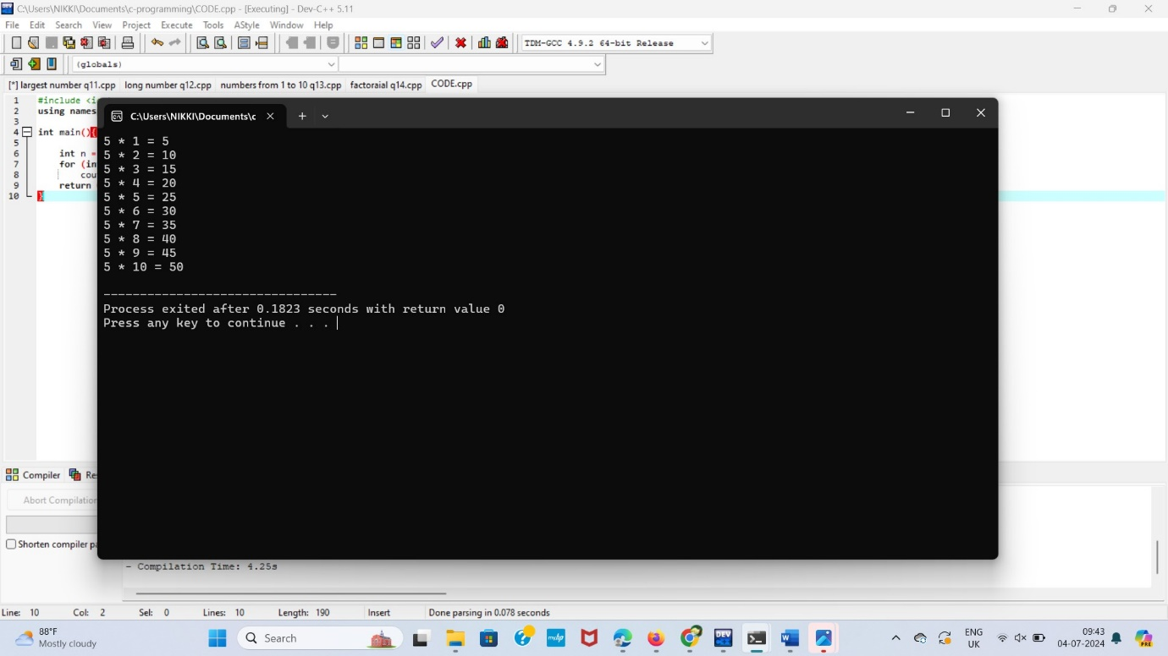

**FIBONACCI SERIES (Q17) Using LOOP:**

#include<bits/stdc++.h>

using namespace std;

int fib(int n)

{

int a = 0, b = 1, c, i;

if( n == 0)

return a;

for(i = 2; i <= n; i++)

{

c = a + b;

a = b;

b = c;

}

return b;

}

int main()

{

int n = 9;

cout << fib(n);

return 0;

}

**Output:**

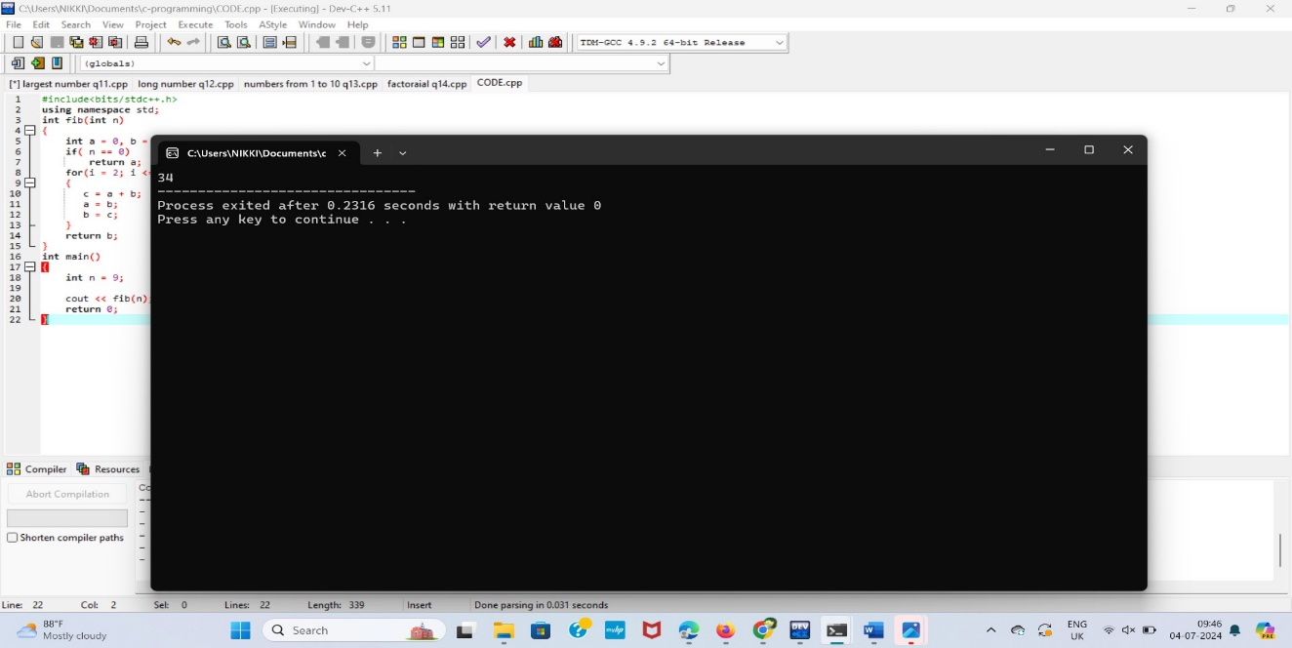

**PRIME NUMBER USING LOOP (Q18)**

#include <bits/stdc++.h>

using namespace std;

bool isPrime(int n)

{

if (n <= 1)

return false;

for (int i = 2; i <= n / 2; i++)

if (n % i == 0)

return false;

return true;

}

int main()

{

isPrime(11) ? cout << " true\n" : cout << " false\n";

isPrime(15) ? cout << " true\n" : cout << " false\n";

return 0;

}

**Output:**

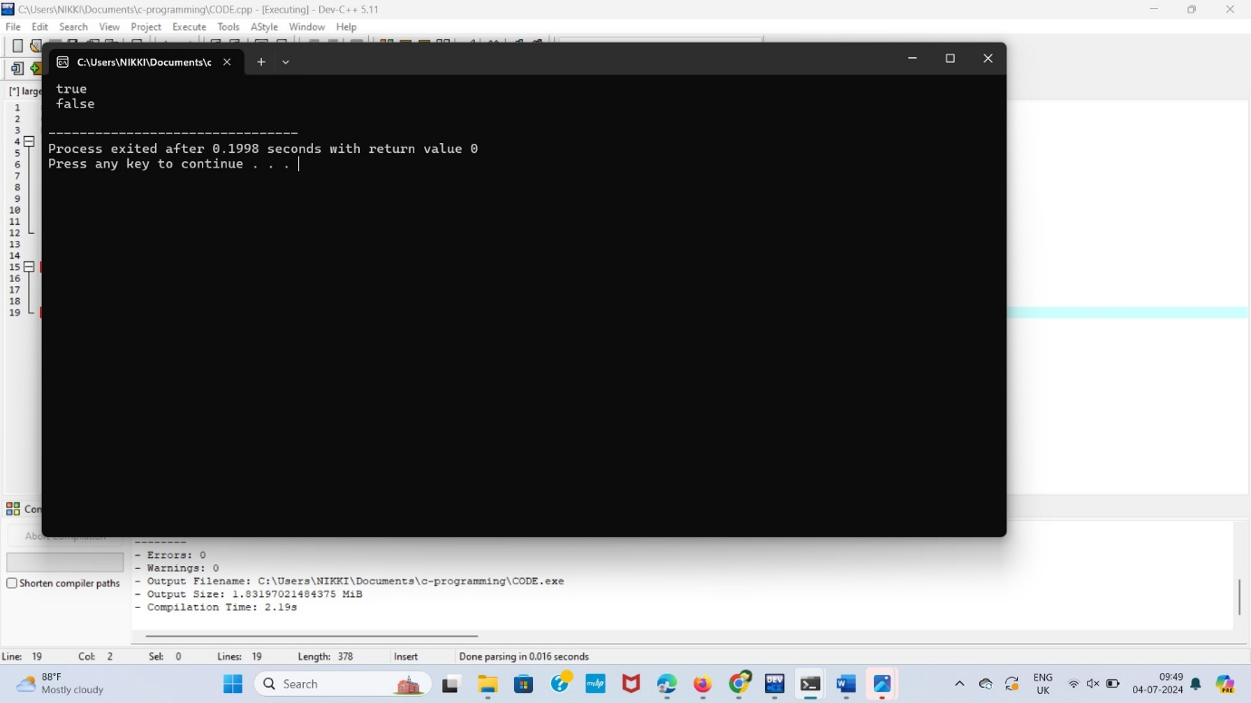

**PALINDROME USING STRING(Q19)**

#include <iostream>

#include <string>

using namespace std;

int main() {

string str;

cout << "Enter a string: ";

cin >> str;

int left = 0;

int right = str.length() - 1;

bool isPalindrome = true;

while (left < right) {

if (str[left] != str[right]) {

isPalindrome = false;

break;

}

left++;

right--;

}

if (isPalindrome) {

cout << "The string is a palindrome." << endl;

} else {

cout << "The string is not a palindrome." << endl;

}

return 0;

}

**Output:**

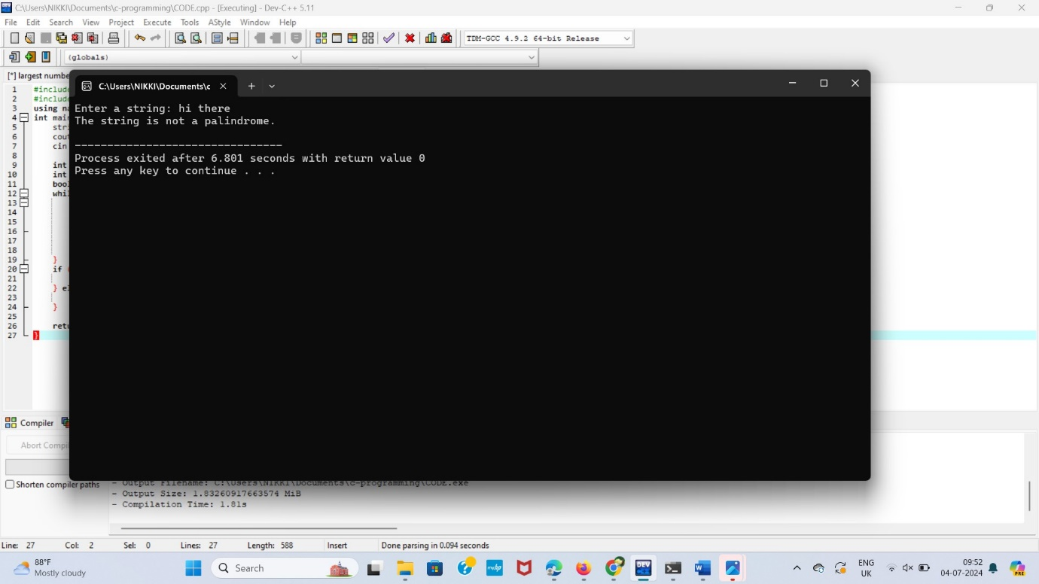

**SUM OF DIGITS (Q20)**

#include <iostream>

using namespace std;

int main() {

int n, sum = 0;

cout << "Enter a number: ";

cin >> n;

int originalNumber = n;

cout << "Sum of digits of " << n << " is: ";

while (n > 0) {

int digit = n % 10;

sum += digit;

n /= 10;

}

cout << sum << endl;

return 0;

}

**Output:**

